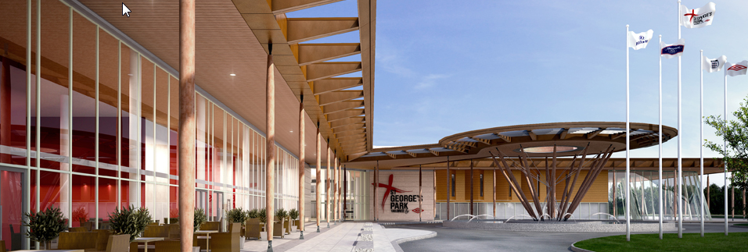  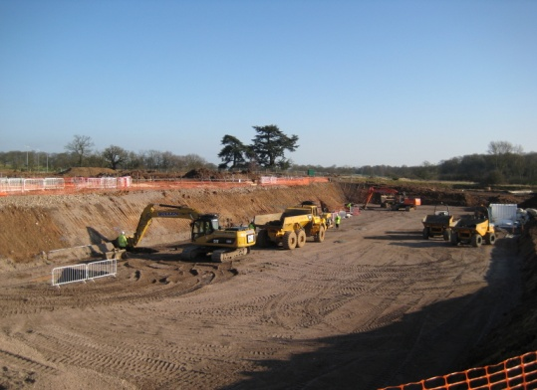  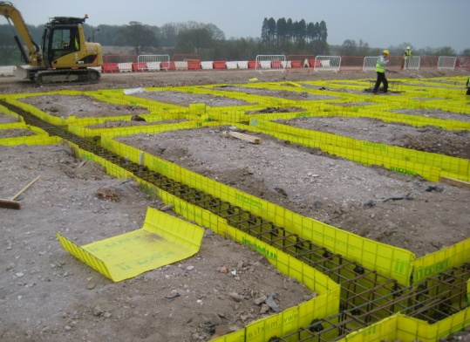  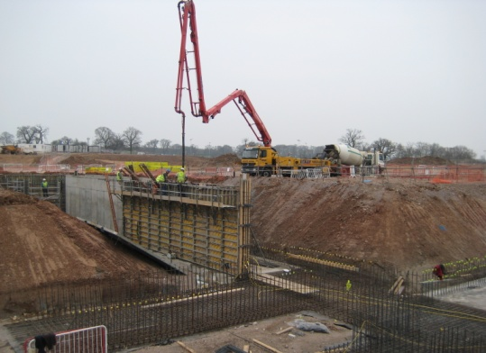 | Project : | St Georges Park - New FA Headquarters and Training Facility, Burton
 | Client: | Bowmer & Kirkland
 | Total Project Value: | £105 Million
 | Subcontract Value: | £6.25 Million
 | Commenced: | February 2011
 | Duration: | 72 Weeks
Scope: Full groundworks package in order to construct the new National FA Headquarters, St Georges Park, Burton.

- Large reinforced foundations and associated ground beams.
- Large piled foundations.
- Foul and surface water drainage systems with excavations reaching up to 9m deep.
- Over 20,000 linear metres of buried services to serve the complex.
- 450m of 4m high retaining walls to form basements and retaining landscape to football pitches.
- Waterproofing to basement walls.
- Hydrotherapy pool pit construction.
- Vast external landscaping of ‘swales’ built into the hillside to form natural drainage and attenuation.
- Large attenuation lake for onsite irrigation system.
- Over 8,000m² granite paving to form pedestrianised areas, footpaths and building borders.

