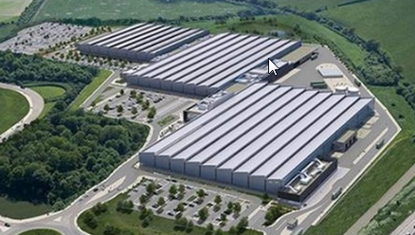  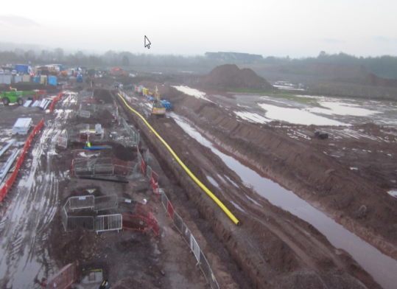  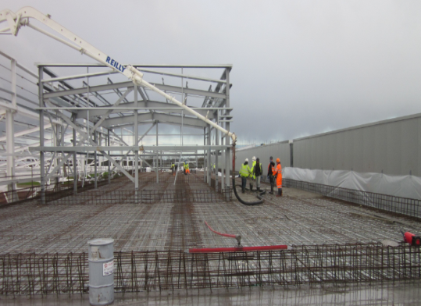  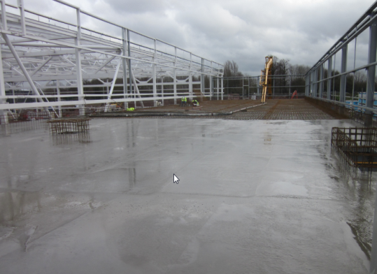 | Project : | Jaguar Land Rover – Engine Manufacturing Facility
 | Client: | Interserve Special Projects
 | Total Project Value: | £500M
 | Subcontract Value: | £11.75M
 | Commenced: | July 2012
 | Duration: | 116 Weeks
Scope: Full groundworks package to build the new engine manufacturing facility involving extensive external and foundation works.

- Extensive de-rocking of sandstone ground.
- Over 600 large reinforced foundations and associated ground beams.
- 3,500m² Ground floor concrete slabs.
- 8,000 Roof slabs and mezzanine decks.
- Foul and surface water drainage systems up to 6m deep, with pipes varying in size from 100mm up to 1,200mm diameter, and manholes up to 4m diameter.
- Excavation and installation of 3 large oil interceptors.
- Installation of 74,000 litre rainwater harvesting tank.
- 3 large bentomat lined attenuation ponds.
- 240 linear metres of gabion walling, and 175m of criblock walling, both to 3.7m high.
- Installation of rapid stack duct box system to facilitate installation of communications, data, HV / LV cabling etc.

