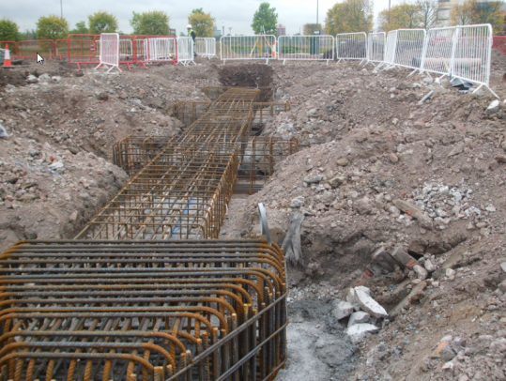  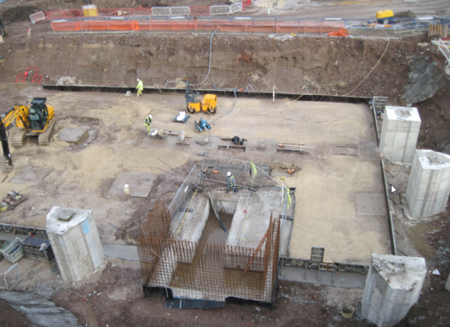  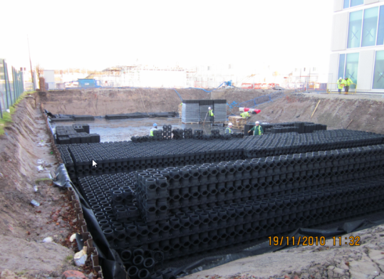  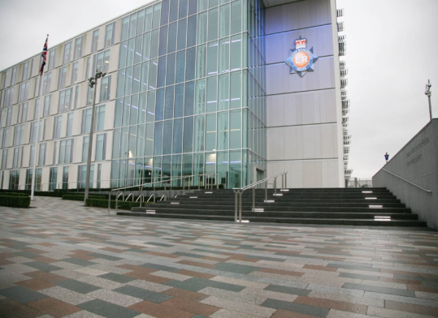 | Project : | Greater Manchester Police HQ and Divisional HQ.
 | Client: | Carillion
 | Total Project Value: | £77M
 | Subcontract Value: | £7.2M
 | Commenced: | July 2009
 | Duration: | 135 Weeks
Scope: Greater Manchester Police commissioned a new Headquarters building consisting of predominantly offices, and a new Divisional Headquarters with both offices and custody suite. Murraywood carried out the full groundworks package.
- Excavation and construction of reinforced concrete foundations and pile caps.
- Installation of foul and surface water drainage systems and associated interceptor and rainwater harvesting tanks.
- Basement construction in both buildings measuring approximately 20m x 15m x 3m.
- Waterproofing to basement.
- 7 upper floors with concrete beam infills and soffit works with perimeter upstands an plinths.
- Over 10,000m² preparation work and asphalt surfacing to car parks.
- External stairway and pedestrianised public realm area laid to granite, with granite clad walls to match.

